

**Software Requirements Specification**

**By Wave Team**

**April 11, 2016**

**Supervised By Dr. Liu Yan**

**Contests**

[1 Introduction 3](#_Toc448367264)

[2 Use Case Modelling 4](#_Toc448367265)

[2.1 Use-case Diagram 4](#_Toc448367266)

[2.2 Activity Diagram 17](#_Toc448367267)

[3 Glossary of Terms 18](#_Toc448367268)

[4 Supplementary Specification 20](#_Toc448367269)

[4.1 Security 20](#_Toc448367270)

[4.2 Performance 21](#_Toc448367271)

[4.3 Data Storage and Computing 21](#_Toc448367272)

[4.4 Track the Package 22](#_Toc448367273)

[4.5 Maintenance 22](#_Toc448367274)

[4.6 Others 22](#_Toc448367275)

[5 User Interfaces 23](#_Toc448367276)

[5.1 Website 23](#_Toc448367277)

[5.2 Mobile Devices (APP) 24](#_Toc448367278)

[6 References 29](#_Toc448367279)

[6.1 Literature Review 29](#_Toc448367280)

[6.2 List of References 30](#_Toc448367281)

[7 Contributions of Team Members 30](#_Toc448367282)

# 1 Introduction

**Purpose** These days as B2C business is increasing rapidly, the growth of logistics business is also remarkable. The enormous market demand brings logistics companies opportunities as well as challenge. Facing such kind of condition, this project is aimed at improving the efficiency of filed personnel and customer satisfaction of a logistics company by building a cross-platform system.

**Definitions** As Jobs has ever said, “People don't know what I really want at all, until your products are in their eyes”. This project is specially designed for an independent logistics companies like UPS. The business scope is limited within China. To be more precise, the express is only available in Jiangsu, Zhejiang and Shanghai at the beginning. The logistics company only serves personal customers and e-business companies with cash-on-delivery express or normal express. The system focuses on logistics service without regard to O2O, bulk cargo or self-support e-business. Timing express might be expanded in future.

**System Overview** The actors in the system are classified as *Postman*, *E-business*, *Customer service*, *Customer* and *Agent*. *Customer* and *Agent* are generalized as *Receiver*. The *Postman* has access to this system only on mobile devices while *Customer* has access both on browsers as well as mobile devises. *E-business* offers orders periodically. *Customer service* helps to deal with tasks cannot be done only by the system.

The system considers all the 8 scenarios, including sending the package, paying for the product, signing the package and so on. To integrate the system, two scenarios are added. One is creating the orders, as the beginning of the entire flow. Another is dealing the order manually, to reduce errors caused by the system and handle other unanticipated situations. That can improve the stability of system and in consideration of the relatively small scale of users in the early stage, robot customer service is not necessary. It can be taken into consideration when the business is expanding to a certain stage.

This project also designs several user interface mock-ups on website and on mobile devices. Core functions are exhibited in these mock-ups, for example the dispatch list interface.

Nonfunctional requirements and further explanations on security, performance, data storage and computing, tracking the package, maintenance and others are detailed in supplementary Specification.

# 2 Use Case Modelling

## 2.1 Use-case Diagram

**2.1.1 Global Use Cases**

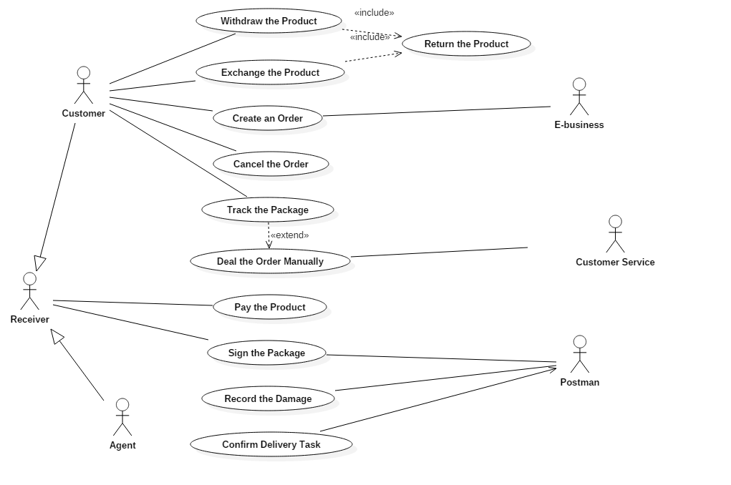

**2.1.2 Sub Use Cases**

Payment View

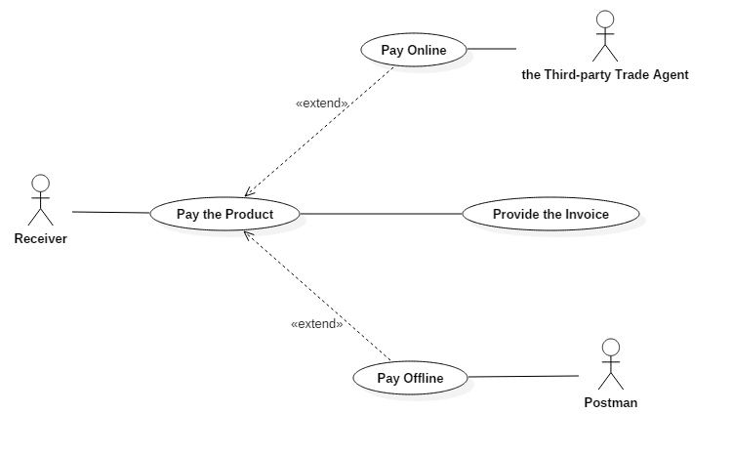

Logistics Company View

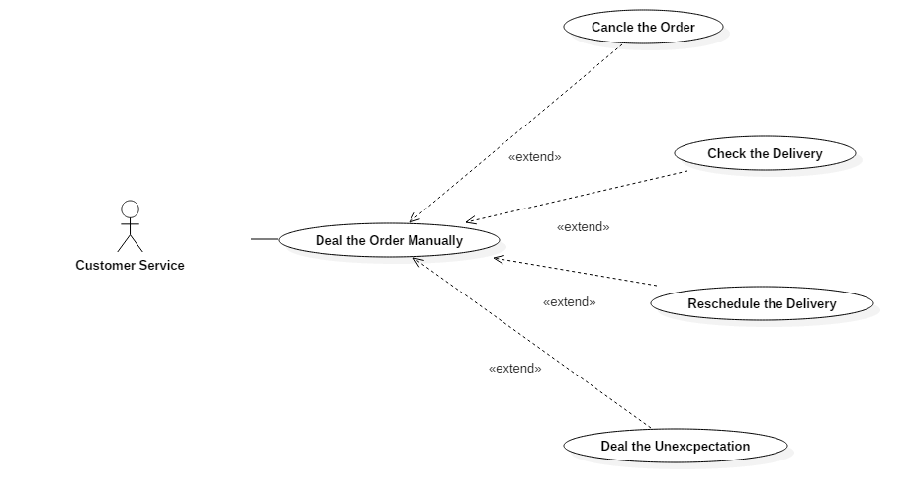

**2.1.3 Specification of Use Cases**

Scenario 1: Create the order

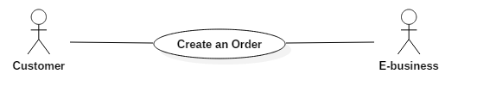

|  |
| --- |
| **Use case: Create an Order** |
| **ID: UC01** |
| **Actors:**  E-business, Customer |
| **Preconditions:**   1. The customer buys products from e-business. He or she can pay for their product when purchasing them online or signing them on-site. 2. If the customer is going to pay on-site, the product will be paid by the logistics company in advance. 3. When the customer is purchasing online, whether he or she pays for the delivery themselves or not, the logistics company gets the payment from the logistics company directly. 4. The customer can also create orders on his/her own. |
| **Basic events:**   1. The customer buys products from e-business and offers his/her information to the e-business. Then he/she will get an order number from the e-business. 2. E-business collects the information and sends to the system periodically. 3. The system creates orders according to the information above. 4. The E-business transfers products to the logistics company and pays for the delivery. If the customer doesn’t pay before, the logistics company will pay for the products for the customer in advance. 5. The customer gets a tracking number, binding to his/her order number, from the system. |
| **Alternative events:**   1. The customer wants to send a package and he/she creates an order through the system. 2. The customer pays for the delivery and transfers the article to the logistics company. 3. The customer gets a tracking number from the system. |
| **Post conditions:**   1. The orders in the system will be scheduled and assigned to different postmen, considering regions and quantities. 2. The information of orders, including tracking numbers, destinations, telephone numbers of customers and so on, will be sent to the corresponding postman by the system, at the same time the packages will be transferred to the postmen. |

**Brief description:**

The E-business creates orders for customers or the customer creates orders on his/her own.

Scenario 2: Send the package

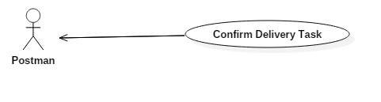

|  |
| --- |
| **Use case: Confirm Delivery Task** |
| **ID: UC02** |
| **Actor:**  Postman |
| **Preconditions:**  1. Orders have been created.  2. The products to be sent have been transferred to the logistics company and have been transported to the regional distribution centers. |
| **Basic flow:**   1. Postmen login the system. 2. The postman gets the packages from the regional distribution center. At the same time, the system sends the information list to the corresponding postman, including tracking number, destination, personal information about receivers, QR code for payment and so on. 3. If the package has no problems, the postman delivers it to the destination and informs the customer to patch it. 4. The GIS will deal the GPS address backstage in the system. If the GPS address of the customer is not in the database, it will be added into the database automatically. |
| **Post conditions:**   1. If the package has problems, the postman must record this in the system. Refer to **Extension use case: Deal with the Expectation.** 2. If no accidents happen in the delivery process, the postman should inform the customer of the delivery terminal and the receiver will sign the package. Refer to **Use case: Sign the Package.** |

**Brief description:**

The postman gets the information of packages to be delivered.

Scenario 3: Sign the package

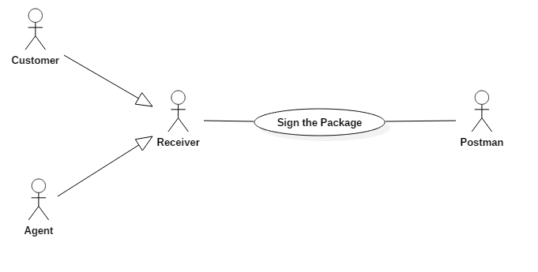

|  |
| --- |
| **Use case: Sign the Package** |
| **ID: UC03** |
| **Actor:**  Postman, Receiver (Generalization of Customer and Agent) |
| **Precondition:**   * + 1. The package has just been sent to the receiver.     2. If the package is going to be received by an agent, the clientage must be confirmed in the system.     3. If the customer has provided the system with his or her fingerprint (or the agent has provided his or her finger print when submitting the clientage), signing by fingerprint is also accept.     4. The Agent can be a third party collection agency.     5. The product has been paid. (If the payment is finished on-site, refer to **Use case: Pay for the Product**) |
| **Basic flow:**   1. Receivers supply their ID-card and phone number to postman. 2. The postman confirms the identity of receivers by checking information on the APP of the system. If the receiver is an agent, the postman should also check the clientage. 3. Receivers check if the product are damaged or lost during the delivery. 4. The postman, has already logged in the system, supplies his or her mobile phone. 5. Receivers sign their name or press their fingerprints on the APP to sign the package. 6. A message will be sent to system, informing the system to confirm the signing. |
| **Alternative flow:**   1. If the identities of receivers are not correct, they cannot sign the package. 2. If the products are damaged or lost during the delivery, receivers can refuse to sign the package. |
| **Post conditions:**  The system will complete the order automatically. |

**Brief description:**

The receiver signs the package on the device of the postman.

Scenario 4: Pay for the product



|  |
| --- |
| **Use case: Pay for the Product** |
| **ID: UC04** |
| **Actor:**  Receiver, Postman, the Third-party Trade Agent |
| **Preconditions:**   1. The order of the product has been sent to receivers. 2. The product has not been paid and the receiver is going to pay for it on-site. 3. Two ways including paying online and paying in cash are provided to receivers. |
| **Basic flow(paying by cash):**   1. The postman checks how much should receivers pay from the APP of the system and verifies it with receivers. 2. Receivers give money to the postman. 3. The postman checks the amount and confirms the payment in the APP of the system. |
| **Alternative flow(paying online):**   1. The postman ask the receivers which kind of method are accepted to finish the payment.    1. Third-party Payment:    2. The postman will show the QR code in his APP to receivers.    3. Receivers scan the two-dimensional code and pay for the product through the third-party payment system.    4. The third-party payment system will add receiver’s payment to company’s account.    5. A message informing the payment will be received by our system from the third-party payment system.    6. The system confirms the payment.    7. Credit Card:    8. The postman will supply the POS device to receivers.    9. Receivers give their Visa card or Union-Pay card to postman.    10. The postman swipes the card and inputs how much should be paid.    11. Receivers input passwords into the POS device.    12. The bank system charges the receivers and adds money to the logistics company’s account, after which they send a message to our system.    13. After the message from Visa or Union-Pay received by the system, the payment will be confirmed. |
| **Post conditions:**   1. After the basic flow, the postman will hand in the money to the logistics company. 2. After both flows, the receiver will sign the package, referring to the **Use case: Sign the Package**. |

**Brief description:**

The products are paid on-site in cash or through the third-party payment agent.

|  |
| --- |
| **Extension use case: Provide the Invoice** |
| **ID: UC05** |
| **Acto**r: Receiver |
| **Precondition**:   1. The package has been signed by Receivers. 2. Receivers have paid for the product. 3. A digital invoice and a paper invoice are provided. |
| **Basic flow**:   1. Receivers login the system and press the button ‘Need the Invoice’. 2. Receivers choose which kind of the invoices they want.    1. Ask for a paper Invoice    2. If receivers need a paper invoice, they should input their address into the system to receive it.    3. System will print the invoice and send the invoice by post service.    4. It’s receivers who supply the postage.    5. Ask for a digital Invoice    6. If receivers need a digital invoice, they need to input an e-mail address into the system to receive it.    7. System will form a digital invoice and e-mail it to the receivers’ e-mail address. |

**Brief description:**

System provides receivers with the invoice.

Scenario 5: The package is damaged or lost

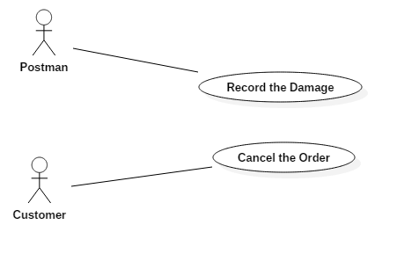

|  |
| --- |
| **Use case: Record the Damage** |
| **ID: UC06** |
| **Actor:**  Postman |
| **Preconditions:**  The product was lost or damaged during the process of delivery. |
| **Basic flow:**   1. The postman records the information of the product into the system. 2. The logistics company receives the corresponding information. 3. The logistics company sends a message to the customer, explaining the situation and making apologies. 4. The customer can choose to deliver the product again at any time or cancel the order，which are provided by the logistics company. |
| **Post conditions:**  1. The customer will get the product he/she wanted originally or just cancel the order freely.  2. The logistics company will pay its price. |

**Brief description:**

Solutions to unforeseen circumstances happened in delivery (Product lost or damage).

|  |
| --- |
| **Use case: Cancel the Order** |
| **ID: UC07** |
| **Actor:**  Customer |
| **Preconditions:**   1. The order has been created by the e-business. 2. The package has been lost or damaged. |
| **Flow of events:**   1. The customer is informed that the package is damaged or lost and he or she chooses to cancel the order. 2. The customer selects reasons for canceling the order. 3. The system confirms the cancel. Refer to **Extension use case: Cancel the Order.** 4. If the customer has paid for the product, the payment will be reimbursed in the way the customer paid for it. |
| **Post conditions:**  The deal will be ended. |

**Brief description:**

It’s a privilege of the customer to cancel the order when the package is missing or damaged.

Scenario 6: Customers are unsatisfied with the product

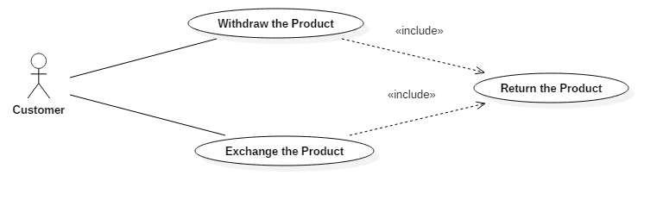

|  |
| --- |
| **Use case: Return the Product** |
| **ID: UC08** |
| **Actor:**  Customer |
| **Preconditions:**  The customer is unsatisfied with the product after receiving it. Therefore, he or she wants to return it within a month. |
| **Basic flow:**   1. The customer logs in the system and makes the request of returning the goods. 2. The system receives the request and provides the customer a label about returning the goods. 3. Both the exchanging process and the cancelling process need the customer to send the package back. |
| **Post conditions:**   1. If the customer chooses to cancel the order, the payment will be reimbursed and the order will be completed. 2. If the customer chooses to exchange the goods, the delivery will be rescheduled upon mutual agreement. |

**Brief description:**

The way for the customer to protect their own rights.

Scenario 7: Track the package

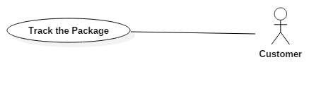

|  |
| --- |
| **Use case: Track the Package** |
| **ID: UC09** |
| **Actors:**  Customer |
| **Preconditions:**   1. The order has been created. 2. The package has not been transferred to the receiver. 3. The customer has obtained the tracking number. 4. The system tracks all the packages, collecting the GPS location at fixed period and inserting new GPS addresses of destinations into the database automatically. |
| **Flow of events:**   1. The customer logins the system. 2. The customer inputs the tracking number. |
| **Post conditions:**   1. The customer can check whether the package to be delivered is picked by the logistics company or not. 2. The customer can gain the real-time information about the package, including the GPS location of that moment, the exact postman, the estimated time of arrival 3. The customer can get informed of if the package is damaged or lost. |

**Brief description:**

The customer tracks the package by using a tracking number.

Scenario 8: Deal the order manually

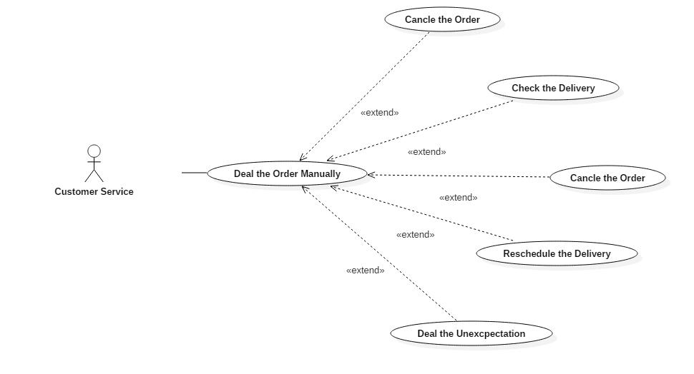

|  |
| --- |
| **Use case: Deal the Order Manually** |
| **ID: UC10** |
| **Actors:**  Customer Service |
| **Preconditions:**   1. The order has been created. 2. The customer has obtained the tracking number. 3. Logistics company customer service has access to the system backstage. |
| **Basic events:**   1. The customer connects with the logistics company customer service for some information. 2. Logistics company customer service gets the information the customers want with the necessary information the customers has offered backstage. |
| **Alternative events:**   1. Logistics company customer service checks operations manually and assists the system in finishing functions requiring manual operations. |

**Brief description:**

Logistics company customer service assists the system by doing which a machine is unable to perform.

|  |
| --- |
| **Extension use case: Track the Package** |
| **ID: UC11** |
| **Insertion segment:**   1. The customer asks the logistics company customer service for the condition of his/her package. 2. The logistics company customer service inputs the tracking number of the customer’s package backstage and gets the real-time information. |

**Brief description:**

Logistics company customer service tracks the package backstage by using the tracking number.

|  |
| --- |
| **Extension use case: Cancel the Order** |
| **ID: UC12** |
| **Insertion segment:**   1. Condition one: The package is damaged or lost and the customer chooses to cancel the order.   Condition two: No one receives the package for a long time.   1. The logistics company customer service confirms the cancel in the system ultimately. 2. If the order is canceled because no one receives the package, the customer will be marked unfaithful by the system. |

**Brief description:**

Logistics company customer service cancels orders backstage.

|  |
| --- |
| **Extension use case: Check the Delivery** |
| **ID: UC13** |
| **Insertion segment:**  After the receiver signs the package, the corresponding information including the data of the received product and customer acceptance will be transferred back to the system and the order will be marked as complete automatically.  If the operation fails by accident. The logistics company customer service will check the delivery manually and mark the order as complete in the system. |

**Brief description:**

Logistics company customer service checks the delivery in case of the accident.

|  |
| --- |
| **Extension use case: Reschedule the Delivery** |
| **ID: UC14** |
| **Insertion segment:**   1. If the customer is not at home and no representative is assigned, the message should be sent back to the system. 2. Logistics company customer service communicates with the customer and obtain his or her agreement. 3. The system reschedules the delivery. 4. When the schedule is made, logistics company customer service sends the information to the customer to ensure he or she would be available to receive the package. 5. Based on the information from the customer, the system will send the available location and time to the postman as a normal order. |

**Brief description:**

Logistics company customer service communicates and helps the system to reschedule the delivery.

|  |
| --- |
| **Extension use case: Deal the Unexpectation** |
| **ID: UC15** |
| **Insertion segment:**   1. If the product is lost or damaged during the delivery, the postman will record the information of the product on this system. 2. The system will then send a message to explain the situation and make apologies to the customer automatically. 3. The customer logins and chooses to deliver the product at any time without any extra fees or cancel the order.    1. If the customer chooses to cancel the order, refer to **Extension Use case: Cancel the Order.**       1. If the customer chooses to deliver the product again, logistics company customer service communicates with the customer and ensures his or her available time and location.       2. The system creates a new order in the e-business system according to the information in the order before and from 4.2.1 and it will be a completely new order for the system.       3. Logistics company customer service checks the reordering operation at regular intervals.       4. Logistic company pays the products and delivery for the customer. |

**Brief description:**

Logistics company customer service assists the system to handle the condition when the package is damaged or lost.

## E:\study\homework\OOAD\assignment1\ActivityDiagram_Delivery.png2.2 Activity Diagram

# 3 Glossary of Terms

* **after-sales service**: Also called customer service, after-sales service is the provision of service to customers before, during and after a purchase.
* **article:** The material in the package which is sent by a normal customer.
* **bi-directional read**: The information can be read in both direction.
* **cash-on-delivery express**: The sale of goods by express where payment is made on delivery rather than in advance.
* **claim**: When packages are damaged or lost, customers have right to ask for compensation.
* **courier**: A courier is a person who delivers messages, packages, and mail. Here it refers to postmen.
* **customer service staff:** The staff in the logistics company serving customers.
* **damaged express item**: The package that is damaged during express.
* **decision support system (DSS)**: A decision support system is a computer-based information system that supports business or organizational decision-making activities.
* **delivery:** A single task to send the package to a customer.
* **delivery terminal:** The destination of the delivery where the receiver receive and sign the package.
* **dispatch list**: The digital list of information of the packages to be delivered in postmen’s port.
* **distribution center**: A station in a large district to transfer packages to the regional distribution center.
* **door-to-cfs**: From the shipper factory or warehouse to the destination or the Container freight station of the discharging port.
* **door-to-door**: From the shipper factory or warehouse to the consignee's factory or warehouse.
* **Electronic Data Interchange (EDI)**: Electronic Data Interchange is an electronic communication method that provides standards for exchanging data via any electronic means.
* **Electronic Order System (EOS)**: Electronic Order System is to meet demand instantly, with perfect quality and punctuality.
* **express item**: Packages to be delivered.
* **express item tracking system**: A sub system in our system to track the packages with GIS automatically.
* **express network**: A service network within the scope to help delivery.
* **express waybill**: An express receipt given by the carrier to the shipper acknowledging receipt of the packages being shipped and specifying the terms of delivery.
* **first time delivery**: The first time for a particular postman to send the package to a position.
* **Global Positioning System (GPS)**: The Global Positioning System is a space-based navigation system that provides location and time information in all weather conditions, anywhere on or near the Earth where there is an unobstructed line of sight to four or more GPS satellites.
* **Geographic Information System (GIS):** A geographic information system is a system designed to capture, store, manipulate, analyze, manage, and present all types of spatial or geographical data.
* **handheld terminal**: Handheld terminal refers to the portable data processing terminal with some particular features. Here it refers to mobile phones with our APP.
* **inquiry**: The customer logins the system or connects with customer service staff to get information about the order, operation instruction etc.
* **Integrated Services Digital Network (ISDN)**: Integrated Services for Digital Network is a set of communication standards for simultaneous digital transmission of voice, video, data, and other network services over the traditional circuits of the public switched telephone network.
* **interchange receipt**: A voucher to certify that the customers or e-business commits articles or products to the logistics company for delivery.
* **Invoice (INV)**: An invoice is a commercial document issued by a seller to a buyer, relating to a sale transaction and indicating the products, quantities, and agreed prices for products or services the seller had provided the buyer.
* **Just-in-time logistics (JIT logistics)**: Just-in-time logistics is a modern logistics method based on the JIT management philosophy.
* **lost express item**: The package that is lost during express.
* **order number**: The number generalized when the order is created.
* **order processing**: A series automatic operation in system to deal the order, such as creating an order, completing an order and so on.
* **package:** The material to be delivered after customers or the e-business company create orders.
* **product:** The material in the package which is ordered by customers from the e-business company.
* **QR code**: QR code (abbreviated from Quick Response Code) is the trademark for a type of matrix barcode (or two-dimensional barcode) first designed for the automotive industry in Japan.
* **Receiver**: Generalized from Customer and Agent, the person receiving and signing the package directly.
* **Redelivery**: When no one can sign the package, the postman will carry it back to the delivery terminal and the order will be rescheduled in the system.
* **redirect express item**: When customer changes the destination or the destination is out of scope, the package will be reassigned.
* **regional distribution center**: The substation in a certain region of the logistics company to assign packages to postmen.
* **Return**: If customers are unsatisfied with the product, he or she can send it back with a label from system.
* **sender**: The customer or the e-business company who sends the package.
* **serial number of express**: i.e. the tracking number of packages in the system.
* **sign in**: The receiver sign the package and get it.
* **sorting**: The packages in the regional distribution center are sorted to transfer to corresponding postmen or the packages in the distribution center are sorted to transport to regional distribution centers.
* **tracking number**: Especially for tracking the real-time GPS location of the package.
* **withdrawal**: If the customer is unsatisfied with the product and has sent it back, he or she can choose withdraw the order and the payment will be reimbursed.

# 4 Supplementary Specification

## 4.1 Security

The system should avoid the database being attacked and data being taken advantage of by the wicked.

**4.1.1 Access and Data Integrity**

1. The authorization of access to the system of postmen, customers and customer servers should be classified and announced clearly. With certain authorization, different users have limited access to data and operation.

2. The server should use anti-virus software.

3. Firewalls and network protection are necessary, and they should be updated in time.

4. The atomic processes in the database will ensure the accuracy of the database.

**4.1.2 Encryption**

1. The session should not be transmitted in DNS.

2. All texts and messages should be transformed into a code which is unreadable.

3. Two keys are used to identify a certain user. One public key is used for encryption and anther private key is used for decryption. The key is a completely random mix of letters.

4. The session will record the activity of the customer, and if the customer has no operation for 5 minutes, he or she will log out the system automatically.

5. After customers log out the system, all the private information (cookies) will be cleaned.

**4.1.3 Digital Certificates**

1. We use digital certificates as a replacement of user names and passwords, for example, SSL Certificates. It will be used automatically with the permission of users.

2. The IP address or location where users login the system will be recorded and when the account is used beyond their regular locations, the user will get alarm.

**4.1.4 Digital Signatures**

1. Users should login the system with a password. Our system will test its complexity. If it is too simple, the system will remind the users to complicate it. That involves cryptography.

2. We use a message digest to ensure the integrality of the data.

3. If necessary, we can extend our fingerprint system to login system.

## 4.2 Performance

4.2.1 The information of the package, including the real-time position, Order-ID, the postman etc., should be checked by customers in 3 seconds with at most 0.1% error rate.

4.2.2 The payment should be confirmed in 2 seconds by the system from the moment when the third party trade agent sends the message or the postmen report the payment.

4.2.3 The order created by customers should be processed in 15 minutes.

4.2.4 The orders obtained from e-business should be processed every hour (about 5,000 orders).

4.2.5 Information of the delivery such as the phone number, the address, the receiver and others should be updated and checked by postman in 1 min.

4.2.6 This system allows the e-business to create batch orders which can be sent at regular time.

4.2.7 The estimate of delivery time should be accurate with the max uncertainty in 2 days.

4.2.8 The expectation should be sent to custom service in 2 min from the time a postman reports it.

4.2.9 This system’s unavailable time should be controlled in 20 minutes in a year.

4.2.10 To offer the best user experience, a content delivery network should be used by this system.

## 4.3 Data Storage and Computing

4.3.1 To store a huge amount of data, distributed database should be used. And it should use Homogeneous DDBMS.

4.3.2 Considering that there may be an enormous number of visitors and inquires at the same time, the system must implement cloud computing service.

4.3.3. The system can support as many as 1500 times of visits per second.

4.3.4 There must be a copy of the database, including device entity, software, data and even employees, in order to prevent some unpredictable disasters.

4.3.5 If the database is destroyed, the copy should be enabled in 3 hours.

4.3.6 The data can be in English, Chinese, Japanese, French and Korean.

## 4.4 Track the Package

4.4.1 In order to track the package, the GIS system should be applied, with the help of the GPS system. The system get geographic information from a third party system, and get the position of postmen who deliver the package through the system of postmen. And this system should match both kinds of the information and show it to users of the system.

4.4.2 The system for postmen should upload the position of the postman automatically every 2 hours, through 3G, 4G or WLAN net.

4.4.3 If the locations of postmen are missing for 4 hours, the system should inform the custom servers, and custom servers will contact with postmen.

## 4.5 Maintenance

4.5.1 The distributed database should be maintained by the employees of our own company including the employees of the stand-by database every day when the visit traffic is not heavy.

4.5.2 The software for custom service, customer and postmen and the system itself should be maintained by our employees.

4.5.3 The geographic information source should be multiple, in case that one of the sources is unavailable.

4.5.4 The engineers from the company offered DBMS will maintain our system every year.

4.5.5 An integrated scheme to deal accidents, for example the crash of database, is necessary.

## 4.6 Others

4.6.1 The architectures of the postman APP and the customer APP are B/S and C/S, but that of custom service is C/S for safety.

4.6.2 Our system can be used in iOS and Android on mobile devices and in a normal browser on PC (Windows/OS/Linux).

4.6.3 Anticipated development time is two months.

# 5 User Interfaces

## E:\study\homework\OOAD\assignment1\web.png5.1 Website

**Figure5.1 The web page of the express system**

There is basic information of the system showed on the page. The services can be ordered on this website after the user logs in. The custom can search for their packages' particulars after logging in. In addition, the significant notations of the sloth express are showed on the web page, such us the forbidden objects etc. Any common browsers of the website can contact the sloth express company and know about the company freely. The service hotline and the QR code are showed in the bottom right corner.

## 5.2 Mobile Devices (APP)

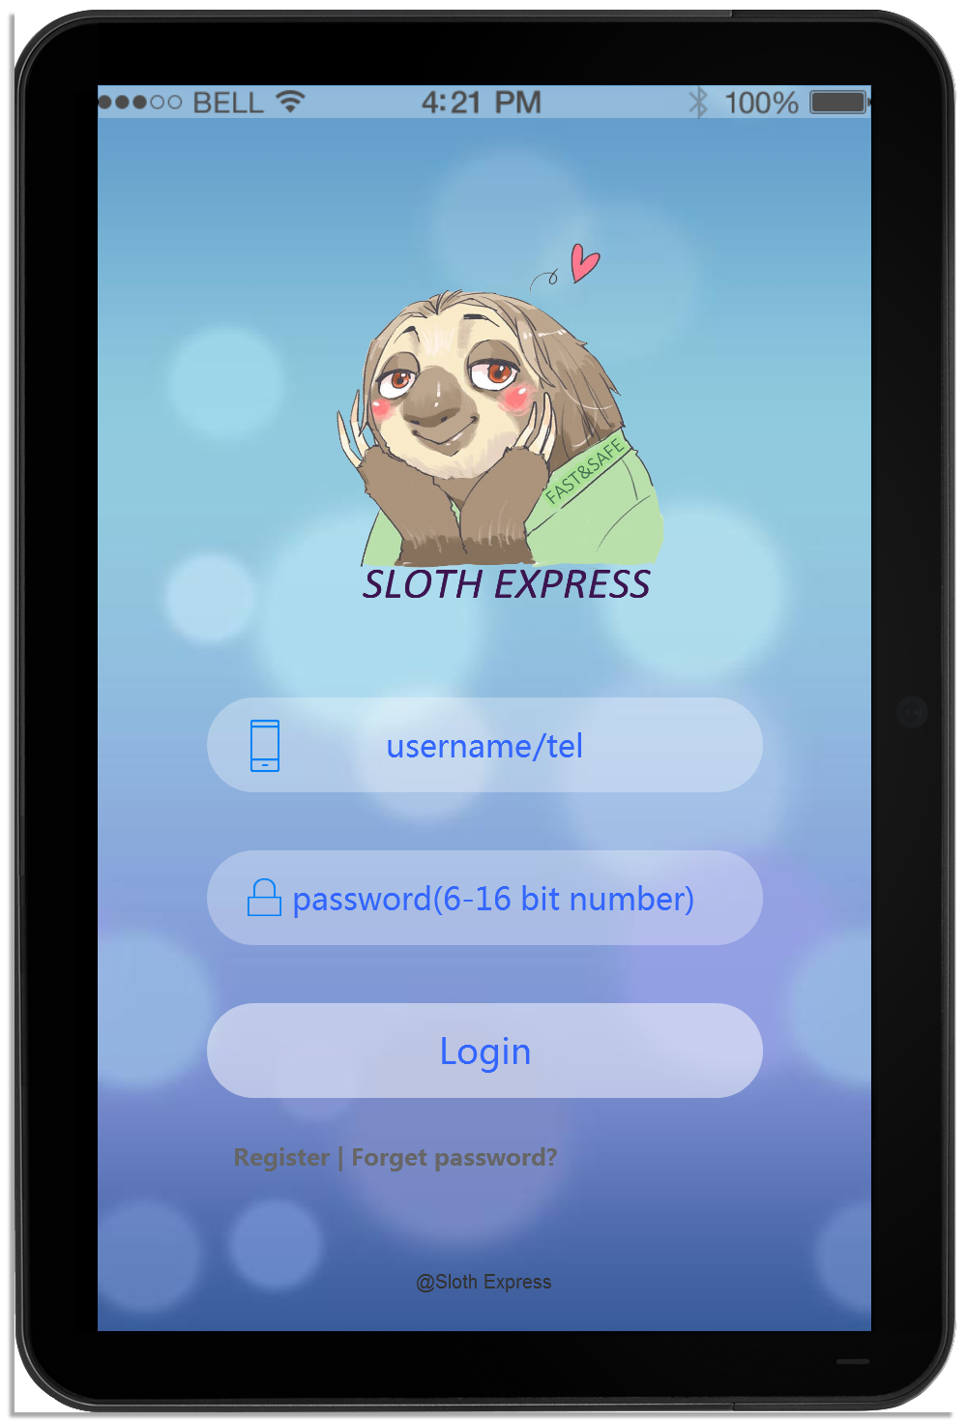

**Figure5.2.1 Home Screen for both the customer and the postman**

The use inputs his/her username and the password into the system. The system will recognize the identities of the users automatically. In addition, this page provides the service of registration and retrieving the password.

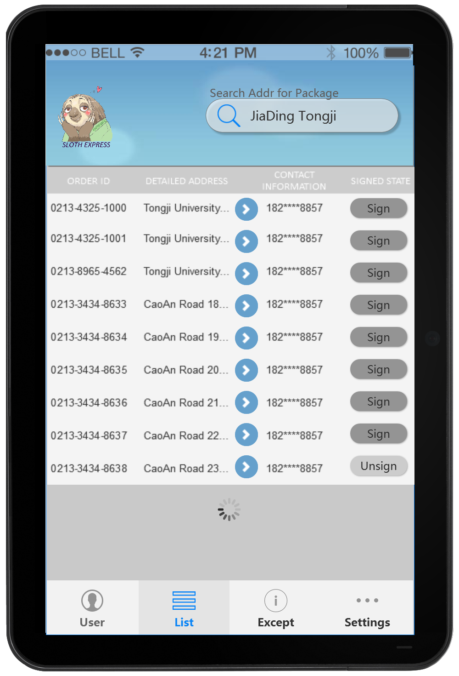

**Figure5.2.2 The product list screen for the postman**

After logging in, the postman will search for the appointed delivery address and then find out all the delivery missions. The postman is able to click the buttons for detailed addresses and look over the delivery status of each order.

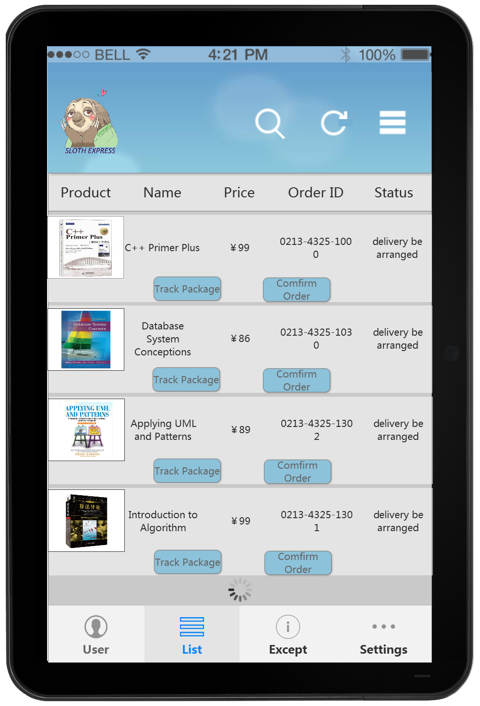

**Figure5.2.3 The delivery particulars screen for the customer**

After logging in, the customer can find his/her order list and the delivery details. The order IDs are provided for specifying each order's delivery information. Tracking the package and confirming the delivery will be recorded in the system.

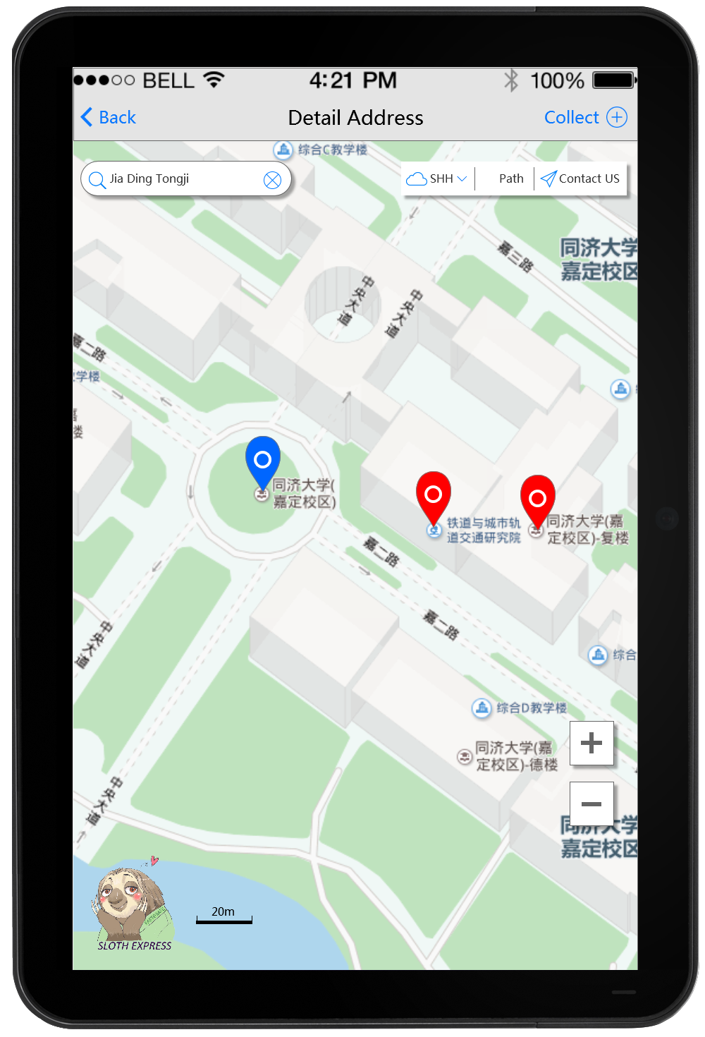

**Figure5.2.4 The address inquiry screen for the postman**

After clicking the buttons for detailed addresses, the postman can get the GPS from a real-time updated map, which enables him to find out where he is and his destinations. The postman can click the top-right button to collect new addresses into the database.

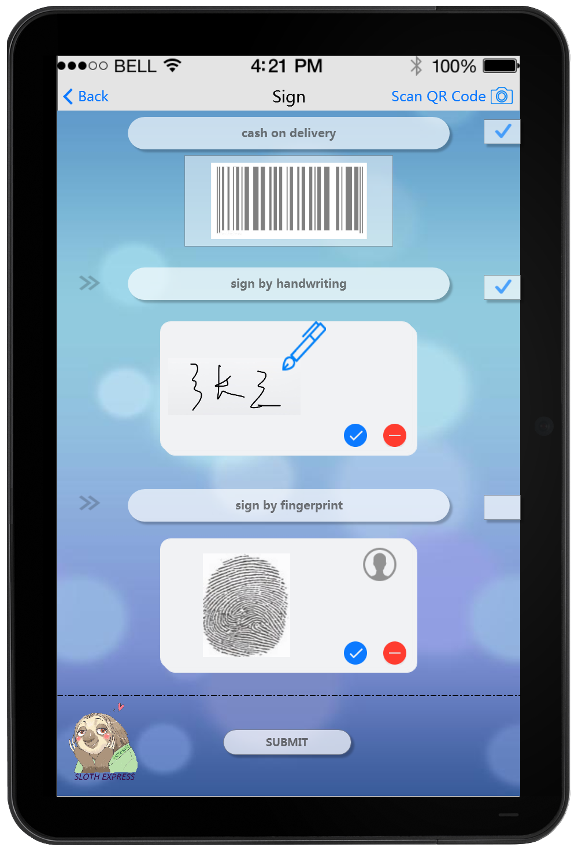

**Figure5.2.5 The signing screen designed for the postman**

After scanning the QR code (button on the top-right), the receiver can sign the package. There are two methods: signatures or a fingerprint. If the product is unpaid, one more column needs to be checked. Click the submit button to complete the delivery.

# 6 References

## 6.1 Literature Review

“Network business security” provides theoretical basis for security defense of enterprise automatic production system and enterprise management information system. It is defined in 3 parts: data security, network system security and network business security.

[reference] K. Wu, T. Zhang, W. Li, G Ma. 2009. *Security Model Based on Network Business Security.* Computer Technology and Development.

A network security system base is designed from the network between the transport layer and application layer. The network system involves digital signature, encryption, decryption, authentication and data transmission function. It has passed the strict test, which means that it realizes a real security of the Internet.

[reference] Z. Huang. 2014. *The Design and Implementation of Security Network System Based on Web.* Advanced Research and Technology in Industry Applications (WARTIA), 2014 IEEE Workshop

The distributed database is a database in which storage devices are not all attached to a common processing unit such as the CPU, and which is controlled by a distributed database management system. In another way, its data is stored in many devices respectively, but they are managed by DDBMS (Distributed Database System).

[reference] O'Brien, J. & Marakas, G.M. (2008). *Management Information Systems* (pp. 185-189). New York, NY: McGraw-Hill Irwin

To serve content to users with high availability and high performance, CDN (Content Delivery Network) is useful. CDN provides storage space to users from respective servers, by choosing which server is best available to terminals. It makes data transfer faster and more steady, so as to offer a better user experience. It can also protect the system from DoS attack.

[reference] Wikipedia. (2016). *Content delivery network*. Retrieved on April 2, 2016. From:

https://en.wikipedia.org/wiki/Content\_delivery\_network

SDN (Software Defined Network) is a solution to computer networking that allows the manager of the network service to administrate the architecture of the net system without changing the physical equipment, just on soft-level. It is more dynamic and cheaper for building and changing the arrangement of the network.

[reference] Wikipedia. (2016). *Software-defined Network*. Retrieved on April 2, 2016. From:

https://en.wikipedia.org/wiki/Software-defined\_networking

To cache dynamic data, the cache has to have certain features: expirations, evictions, caching relational data, synchronizing a cache with other environments, database synchronization, read-through, write through & write behind, cache query, event propagation, cache performance and scalability, high availability and performance.

[reference] Khan, Iqbal*. "Distributed Caching On The Path To Scalability".* MSDN (July 2009). Retrieved 2012-03-30*.*

## 6.2 List of References

[1] J. Pan. (2013). *Software Methodology, Volume 1, Business Modeling and Requirements.* Tsinghua University Press

[2] Paul, S; Z Fei (2001-02-01). *"Distributed caching with centralized control".* *Computer Communications* 24 (2): 256–268

[3] Wikipedia. (2016). *Electronic business*. Retrieved on April 2, 2016. From:

https://en.wikipedia.org/wiki/Electronic\_business#Security.

# 7 Contributions of Team Members

**1452693 Wang Guansong** Use Case, Activity Diagram, UI 20%

**1452712 Wang Jiahui** Use Case, Presentation, Activity Diagram, Document 20%

**1452716 Zhang Yinjia** Use Case, Activity Diagram, Document 20%

**1452762 Zhu Fangrui** Use Case, Presentation, UI 20%

**1452768 Ji Xunzhen** Use Case, Activity Diagram, UI 20%